CPE477/ECG677 – Embedded Security & Machine Learning

Design Assignment 1

DO NOT REMOVE THIS PAGE DURING SUBMISSION:
Name: Carlos Funes
Group-Partner Name: Jabril Smith
Email: funesc2@unlv.nevada.edu
Github Repository link (root): https://github.com/CaFu0320/senna/tree/main/DA1%20ECG677
Youtube Playlist link (root): https://youtube.com/playlist?list=PLJA7XbPFqFcc&si=U-yH8oLULGEhojNk
Follow the submission guideline to be awarded points for this Assignment.
Submit the following for all Assignments:
- In the document, for each task submit the modified or included code (from the base code) with highlights and justifications of the modifications. Also include the comments. If no base code is provided, submit the base code for the first task only.
- Create a private Github repository with a random name (no CPE477/677, Lastname, Firstname). Place all assignments under the root folder, sub-folder named Assignmentn, with one document and one video link file for each lab, place modified c files named as main.c.
- If multiple ‘c’ or ‘h’ files or other libraries are used, place these files inside the folder.
- The folder should have a) Word document (see template), b) source code file(s) with other ‘c’ and ‘h’ include files, c) text file with youtube video links (see template).
- Submit the pdf file in canvas before the due date. The root folder of the github assignment directory should have the documentation and the text file with youtube video links.
- Organize your youtube videos as playlist under the name “EMBSEC&ML”. The playlist should have the video sequence arranged as submission or due dates.
- Only submit pdf documents. Do not forget to upload this document in the github repository and in the canvas submission portal.
Declaration
I understand the Student Academic Misconduct Policy - http://studentconduct.unlv.edu/misconduct/policy.html

“This assignment submission is my own, original work”.
Carlos Funes
Report Content:

Each report should contain the content outlined below. These items serve as general guidelines; the specific content required will depend on the objectives and outcomes to be demonstrated in each assignment.

- Abstract: In one short paragraph, state the goal of the design assignment, summarize what was achieved, and briefly describe the approach used to achieve it.
- Schematics: Provide a complete schematic or wiring diagram of the hardware setup. Label every pin, port, and peripheral used, and describe the function of each connection.
- Task results: For each sub-goal or task, describe the experimental setup, present the data collected, visualize the data (plots, tables, or screenshots), and analyze the results. Comment on the outcome, state what was achieved, and document any issues or shortcomings encountered.
- Dependent tasks: When a sub-goal or task builds on a previous one, include the same items listed above (setup, data, visualizations, analysis, and outcome). In addition, explicitly compare the results with the previous task, explain what changed or improved, and document any issues or shortcomings encountered.
- Conclusion: Summarize the overall design assignment, including what was achieved, the key issues or shortcomings, and possible improvements or next steps.
- References: List any datasheets, documentation, libraries, code sources, or other external resources used.

Design Assignment 1 Report
High-Speed IMU and Magnetometer Data Acquisition, Calibration, Orientation, and Visualization
STM32F401RE-NUCLEO + X-NUCLEO-IKS4A1
LSM6DSV16X IMU + LIS2MDL Magnetometer

1. Abstract
The objective of Design Assignment 1 was to develop a high-speed sensor data acquisition and processing system using the STM32F401RE-NUCLEO board with the LSM6DSV16X accelerometer and gyroscope and the LIS2MDL magnetometer for use in human activity recognition (HAR). The system was configured to acquire measurements through I2C, perform manual calibration to acquire the scale and bias. Also to estimate roll, pitch, and yaw using sensor fusion, stabilize the true measurements through normalization and the complementary filter, calculate euler angles and quaternion orientation values, and transmit the processed information as CSV data through UART. A data-ready interrupt from the IMU was used to support high-speed acquisition, with a polling fallback implemented for reliability. A Python graphical user interface was also developed to receive, record, and visualize the accelerometer, gyroscope, magnetometer, euler and orientation measurements in real time.

2. Schematics

The hardware consists of an STM32F401RE-NUCLEO development board with the X-NUCLEO-IKS4A1 motion-sensor expansion board. The LSM6DSV16X six-axis IMU and LIS2MDL three-axis magnetometer communicate with the STM32 through I2C1. The IMU data-ready signal is routed to PB5 and configured as a rising-edge external interrupt. USART2 provides serial communication to the PC through the NUCLEO virtual COM port, and TIM2 provides the time base used for sample-to-sample integration.
Connection / Peripheral | MCU / Interface | Device / Signal | Purpose
I2C1 | 400 kHz | LSM6DSV16X, LIS2MDL | Sensor configuration and data reads
IMU INT1 | PB5 / EXTI5 | LSM6DSV16X INT1 | Signals new accelerometer/gyroscope data
USART2 | 921600 baud, 8N1 | PC virtual COM port | High-speed CSV transmission
TIM2 | 1 us timer tick | Firmware timing | Computes dt for integration
PC13 | User button B1 | Calibration reset input | Resets calibration trackers
LD2 | On-board LED | Interrupt/error indicator | Visual interrupt and error feedback

Physical Hardware setup:
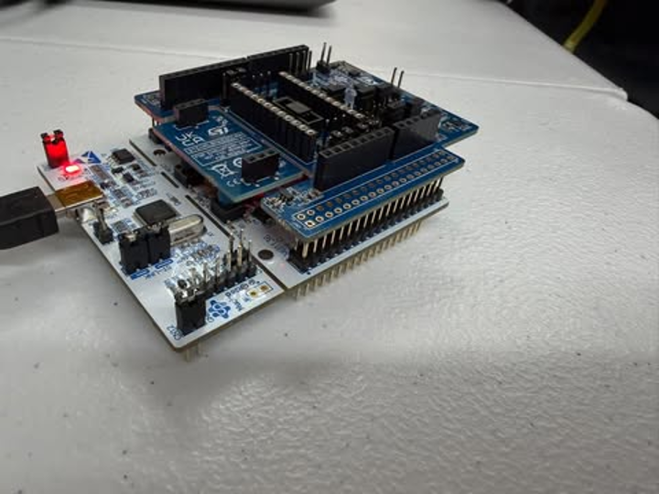
CubeMX PinOut View
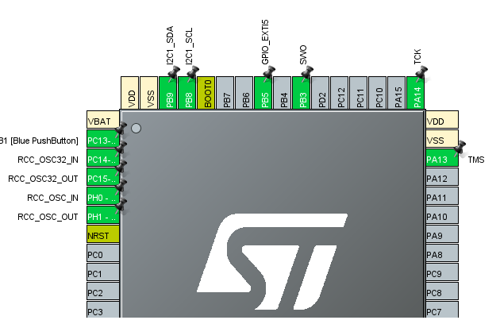
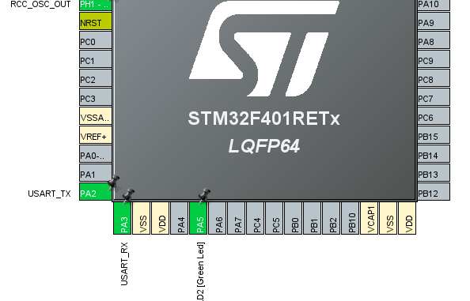
Schematic of what was used
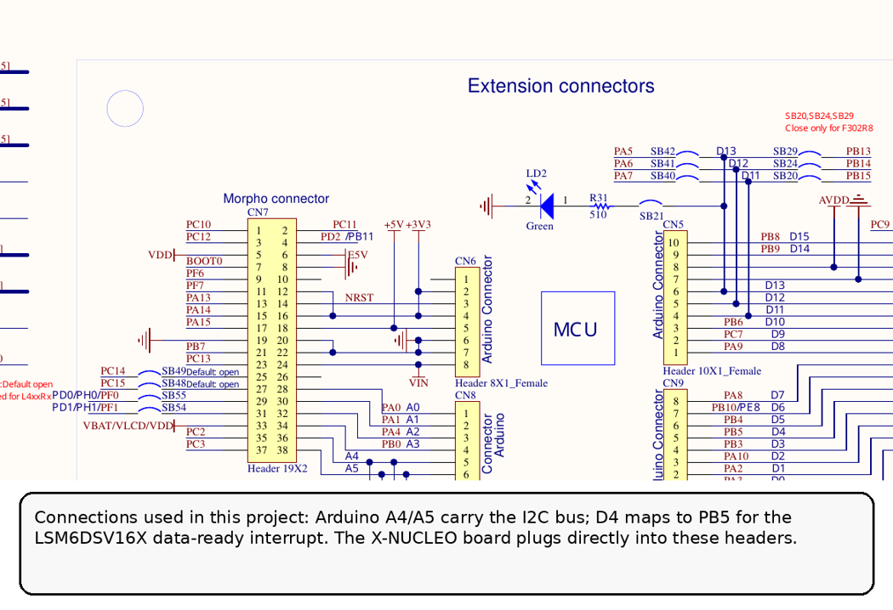

3. Task Results

3.1 Sensor Configuration and Raw Data Collection
At startup, the firmware checks the WHO_AM_I registers of both sensors before beginning acquisition. The LSM6DSV16X is expected to return 0x70 and the LIS2MDL is expected to return 0x40. The IMU is configured in high-performance mode at 240 Hz with an accelerometer range of +/-8 g and a gyroscope range of +/-2000 deg/s. Block Data Update and register auto-increment are enabled so a multi-byte read returns a coherent sample. The LIS2MDL is configured for continuous conversion at 100 Hz with temperature compensation and Block Data Update enabled. I2C1 operates at 400 kHz.
#define IMU_ODR_REG_VALUE LSM6DSV16X_ODR_HP_240HZ
#define LSM6DSV16X_FS_XL_8G 0x02U
#define LSM6DSV16X_FS_G_2000DPS 0x04U
IMU_WriteReg(LSM6DSV16X_ADDR, LSM6DSV16X_CTRL3, 0x44);
IMU_WriteReg(LSM6DSV16X_ADDR, LSM6DSV16X_CTRL1_XL, IMU_ODR_REG_VALUE);
IMU_WriteReg(LSM6DSV16X_ADDR, LSM6DSV16X_CTRL2_G, IMU_ODR_REG_VALUE);
IMU_WriteReg(LIS2MDL_ADDR, LIS2MDL_CFG_REG_A, 0x8C);
The IMU is read using a 12-byte burst transaction containing gyroscope X/Y/Z followed by accelerometer X/Y/Z. Raw signed 16-bit values are converted to physical units using the configured sensor sensitivities. Magnetometer data are converted using 0.15 uT/LSB. Because the magnetometer updates more slowly than the IMU, the firmware only replaces the magnetic values when the LIS2MDL reports new XYZ data; otherwise the most recent magnetic sample is reused.

3.2 Interrupt-Based High-Speed Acquisition
The LSM6DSV16X data-ready interrupt is used to trigger acquisition. PB5 is configured as a rising-edge EXTI input. The STM32 interrupt file contains EXTI9_5_IRQHandler(), which calls HAL_GPIO_EXTI_IRQHandler(GPIO_PIN_5). The HAL callback in main.c then increments an interrupt counter and sets the volatile imu_data_ready flag. The main loop waits for this flag before reading a new IMU sample.
void EXTI9_5_IRQHandler(void)
{
HAL_GPIO_EXTI_IRQHandler(GPIO_PIN_5);
}

void HAL_GPIO_EXTI_Callback(uint16_t GPIO_Pin)
{
if (GPIO_Pin == GPIO_PIN_5)
{
imu_irq_count++;
imu_data_ready = 1;
HAL_GPIO_TogglePin(LD2_GPIO_Port, LD2_Pin);
}
}
A 20 ms timeout and STATUS_REG polling fallback are also implemented. If an expected interrupt does not arrive, the firmware checks whether accelerometer or gyroscope data are available and continues instead of hanging indefinitely. This makes the acquisition path easier to debug while preserving interrupt-driven operation when the INT1 signal is functioning correctly.

3.3 Manual Calibration and Normalization
Manual calibration is performed in the MCU. There was test code that tracked accelerometer and magnetometer minimum and maximum and accumulates stationary gyroscope readings. Accelerometer bias is calculated as (max + min)/2 and scale as 1/((max - min)/2). Magnetometer bias is calculated from the midpoint of each axis range, and axis-dependent scale factors compensate for distortion. Gyroscope zero-rate bias is obtained from the average stationary output. During normal operation, bias is subtracted from each measurement and the accelerometer/magnetometer scale factor is then applied.
Sensor axis | Bias used | Scale used
Accel X | -0.019 | 0.088
Accel Y | -0.153 | 0.0964
Accel Z | 0.250 | 0.0798
Mag X | -38.025 uT | 0.912
Mag Y | 8.55 uT | 1.019
Mag Z | -7.275 uT | 1.0835
Gyro X | 2.89 deg/s | N/A
Gyro Y | -4.43 deg/s | N/A
Gyro Z | -3.63 deg/s | N/A

// accelerometer calibration: [-11.356, 11.318, -10.526, 10.22, -12.28, 12.78], -46.35, -46.35, 20.70, 20.70, 27.15, 27.15, 9785.30, -9866.34, -4793.50, 2526,
// magnetometer calibration: -29.979, 8.487, -23.361, 27.62, -12.49, 16.15, [-46.35, -46.35, 20.70, 20.70, 27.15, 27.15], -8510.20, -50142.75, 34587.75, 3831
// gyro calibration: -0.610, 0.605, -0.318, 0.56, 9.72, 10.41, -46.35, -46.35, 20.70, 20.70, 27.15, 27.15, [4755.86, -7290.44, -5970.99, 1644]

3.4 Filtering and Euler Angles
Roll and pitch are estimated with a complementary filter using ALPHA = 0.98. Gyroscope integration provides the fast rotational response, while accelerometer-based angles slowly correct drift. Yaw is corrected using the LIS2MDL magnetic heading. Before calculating heading, the magnetic vector is tilt-compensated using the current roll and pitch estimates. The magnetic heading is then blended with integrated Z-axis gyroscope motion, with angle wrapping handled across +/-180 degrees.
#define ALPHA 0.98f
roll = ALPHA * (roll + gyro_x_true * dt) + (1.0f - ALPHA) * roll_acc;
pitch = ALPHA * (pitch + gyro_y_true * dt) + (1.0f - ALPHA) * pitch_acc;
float yaw_gyro = yaw + gyro_z_true * dt;
float yaw_err = WrapDeg(psi - yaw_gyro);
yaw = WrapDeg(yaw_gyro + (1.0f - ALPHA) * yaw_err);

3.5 Quaternion Calculation
A quaternion representation of orientation is produced. The calibrated gyroscope rates are converted to radians per second and used to calculate the quaternion derivative. A gyro-propagated quaternion is blended with a reference quaternion derived from the fused roll, pitch, and yaw values. The final quaternion is renormalized so its magnitude remains approximately one. This provides an orientation representation that is useful for machine-learning or HAR processing and avoids relying on Euler angles alone.

3.6 UART and CSV Data Collection
USART2 is configured at 921600 baud, 8 data bits, no parity, and one stop bit. In normal mode, each transmitted CSV row contains 16 processed values: calibrated acceleration, calibrated angular velocity, calibrated magnetic field, Euler angles, and quaternion values. The output order is ax, ay, az, gx, gy, gz, mx, my, mz, roll, pitch, yaw, qw, qx, qy, qz.
Item | Configured / measured value | Meaning
IMU output data rate | 240 Hz | LSM6DSV16X configuration
Magnetometer output data rate | 100 Hz | LIS2MDL configuration
I2C1 | 400 kHz | Sensor bus clock
USART2 | 921600 baud, 8N1 | Serial output configuration
Measured dashboard receive rate | 46 rows/s | Observed PC-side CSV throughput

The measured dashboard receive rate should not automatically be reported as the physical IMU ODR. It represents end-to-end rows received by the PC. Current bottlenecks include blocking I2C reads, blocking UART transmission, floating-point snprintf formatting, the 100 Hz magnetometer/240 Hz IMU rate mismatch, and PC/USB scheduling. The current normal-mode row also does not contain a sequence number, so the PC cannot prove whether an individual sample was lost in transit.
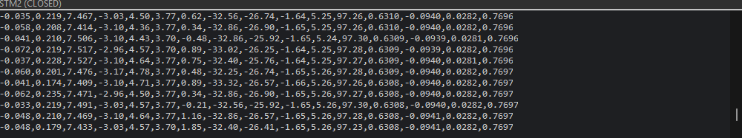

3.7 Graphical Visualization and CSV Recording
A Python graphical user interface was developed using Tkinter, Matplotlib, and PySerial. The program lists available serial ports, supports several baud rates including 921600, opens the selected serial port in 8N1 mode, and parses supported CSV formats. It displays four real-time graph groups: acceleration X/Y/Z, angular velocity X/Y/Z, magnetic field X/Y/Z, and roll/pitch/yaw orientation. Serial reading is performed in a worker thread, while plotting is refreshed separately so display updates do not directly block the serial read loop. The GUI can also record accepted rows to a CSV file for later analysis.
The dashboard does not recalibrate, filter, or recompute orientation. It displays the values transmitted by the STM32 firmware. Therefore, the report screenshots represent the embedded processing performed on the MCU. The firmware uses 921600 baud, so the dashboard baud selector must be changed to 921600 before connecting.
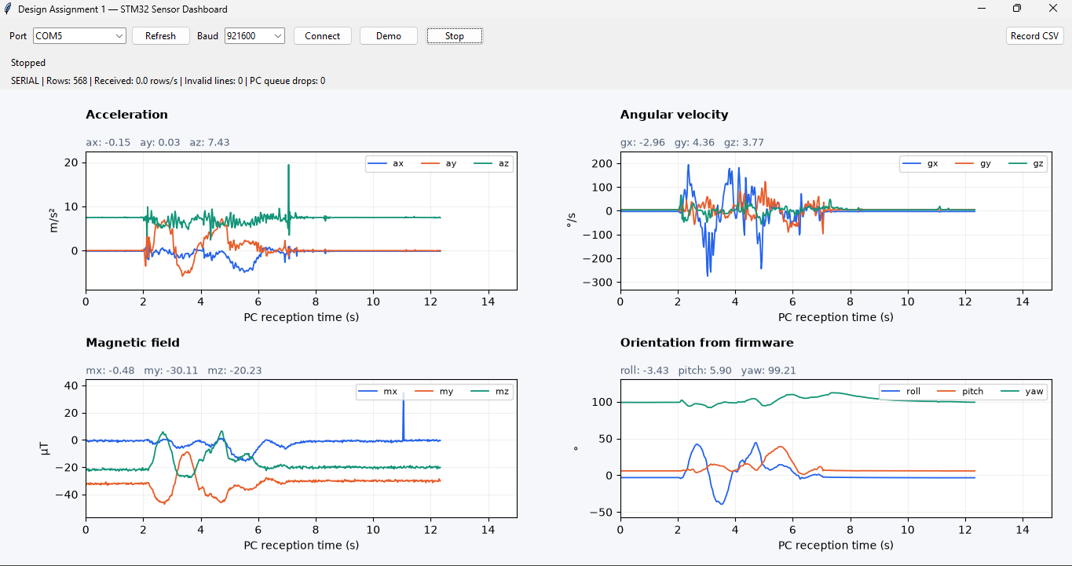

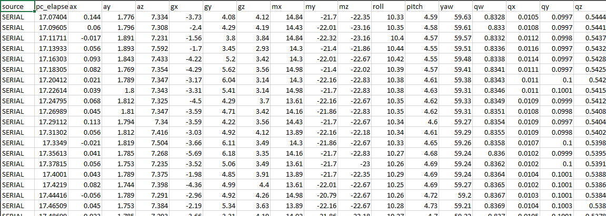

3.8 Issues and Shortcomings Observed
The current design is functional but has several limitations. The GUI reports PC reception throughput rather than exact sensor sampling rate. The normal-mode firmware prints a header beginning with t_us even though the 16-value data rows do not currently transmit that timestamp. The GUI defaults to 115200 baud while the program uses 921600, so the baud value must be changed before connection. Yaw can be affected by magnetic disturbances and sensor-axis alignment. The complementary-filter coefficient is fixed at 0.98 rather than experimentally tuned for each activity. Finally, blocking HAL calls and ASCII floating-point CSV are simple to verify but are less efficient than DMA and compact binary packet transmission.

4. Dependent Tasks
The tasks in this assignment were sequentially dependent. Initial testing first established communication with the LSM6DSV16X and allowed accelerometer and gyroscope data to be collected. The LIS2MDL magnetometer was then added, expanding the system to nine-axis sensing. Manual calibration was required before the sensor outputs could be used reliably for orientation estimation. The calibrated accelerometer and gyroscope values were then used for roll and pitch estimation, while the calibrated magnetometer supplied the heading reference required to correct yaw. After basic sensor acquisition worked, the LSM6DSV16X data-ready signal was integrated through PB5/EXTI to make acquisition event-driven, with a polling fallback retained for reliability. Finally, the processed UART stream was connected to the Python dashboard for visualization and CSV recording.
Stage | What changed or improved
Initial IMU communication | Accelerometer and gyroscope measurements became available.
Magnetometer integration | Added three-axis magnetic-field data and a heading reference.
Manual calibration | Removed measured offsets and applied axis-dependent correction.
Complementary filtering | Combined sensor strengths to produce roll, pitch, and yaw.
Quaternion output | Added a normalized four-component orientation representation.
Data-ready interrupt | Changed acquisition from simple polling toward event-driven sampling.
Python dashboard | Added live visualization, receive-rate reporting, and CSV recording.

Compared with the earlier sensor-reading stages, the final system therefore adds calibration, normalization, filtering, Euler angles, quaternion orientation, interrupt-driven acquisition, high-speed UART output, and PC-side visualization. Each stage depended on the previous stage producing usable data, so problems found in sensor configuration or calibration directly affected later orientation and visualization results.

5. Conclusion
Design Assignment 1 produced an embedded sensing pipeline for high-speed human-activity data collection using the STM32F401RE-NUCLEO and X-NUCLEO-IKS4A1. The final firmware communicates with the LSM6DSV16X and LIS2MDL through I2C, converts raw measurements to physical units, applies manually determined calibration values, estimates roll, pitch, and yaw using complementary filtering, generates normalized quaternion values, and transmits the processed measurements through high-speed UART as CSV data. The LSM6DSV16X data-ready interrupt is handled through PB5/EXTI, while a polling fallback prevents the loop from stopping if an interrupt is missed. A Python dashboard provides real-time visualization and CSV recording. The primary remaining limitations are blocking communication calls, ASCII floating-point transmission overhead, different IMU and magnetometer update rates, sensitivity of yaw to magnetic disturbances, and the lack of a transmitted sequence number/timestamp for rigorous loss and timing analysis. Future improvements could include DMA-based I2C/UART transfers, compact binary packets, device-side sequence numbers and timestamps, more advanced sensor-fusion algorithms, and a larger labeled HAR dataset.

6. References
- STMicroelectronics, LSM6DSV16X 6-axis IMU datasheet and register documentation.
  - https://www.st.com/en/mems-and-sensors/lsm6dsv16x.html
- STMicroelectronics, LIS2MDL 3-axis magnetometer datasheet and register documentation.
  - https://www.st.com/en/mems-and-sensors/lis2mdl.html#documentation
- STMicroelectronics, STM32F401RE and NUCLEO-F401RE documentation.
  - https://components101.com/microcontrollers/stm32-nucleo-f401re-pinout-datasheet
- Steppeschool Estimation Explained: Rotation Matrices, Euler angles, Quaternions, and Sensor Fusion
  - https://www.steppeschool.com/blog/attitude-estimation-rotation-matrices-quaternions-sensor-fusion
- X-NUCLEO-IKS4A1 data
  - https://www.st.com/en/evaluation-tools/x-nucleo-iks4a1.html#cad-resources
- NUCLEO-F401RE data
  - https://www.st.com/en/evaluation-tools/nucleo-f401re.html#cad-resources

